**23CSE111**

**OBJECT ORIENTED PROGRAMMING**

**LAB REPORT**



**Department of Computer Science Engineering**

**Amrita School of Computing**

**Amrita Vishwa Vidyapeetham, Amaravati Campus**

**NAME :G. Manideep**

**Verified By Roll No: AV.SC.U4CSE24108**

|  |  |  |  |  |
| --- | --- | --- | --- | --- |
| S. No |  | Date | Page No | Signature |
| ***LAB 1*** |  |  |  |  |
| ***a*** | How to download jdk-21 in your pc |  |  |  |
| ***b*** | Set environment Variables in your pc |  |  |  |
| ***c*** | Checking of jdk-21 version is |  |  |  |
| ***d*** | Write a simple java program to about an student |  |  |  |
|  |  |  |  |  |
| ***LAB 2*** |  |  |  |  |
| **1** | Simple Java Program for finding simple interest by taking input from User |  |  |  |
| **2** | Write a simple program to calculate factorial of a number and read the input from user |  |  |  |
| **3** | Write a program to to calculate the fibonacii sequence and take the input from user |  |  |  |
| **4** | Write a java program to convert temperature from Fahrenheit to celsius and take the input from user |  |  |  |
| **5** | Write a simple program to find the area of rectangle and take the input from user |  |  |  |
| **6** | Write a java program to convert temperature from Celsius to Fahrenheit |  |  |  |
| **7** | Write a program to find the area of triangle by using heron’s formula take the input from the user |  |  |  |
|  |  |  |  |  |
| ***LAB 3*** |  |  |  |  |
| **1** | create a java program with following instructions |  |  |  |
| 2 | To create a class bankAccount with methods deposit and withdrawl |  |  |  |
|  |  |  |  |  |
| **LAB 4** |  |  |  |  |
| 1 | create a java program with following instructions |  |  |  |
| 2 | To create a class bankAccount with methods deposit() and withdrawl |  |  |  |
|  |  |  |  |  |

**WEEK-1**

**1) Explain the process of Installing JDK (Java Development Kit)**

**Installing of JDK (Java Development Kit):**

1. **Download JDK:**
   * Go to the Oracle JDK download page in your web browser and click on JDK-21 version which is Long term support (LTS) version.
   * Click on the download link for your operating system (Windows, macOS, or Linux).
2. **Install JDK:**
   * Once downloaded, run the installer.
   * Follow the instructions and keep clicking "Next" until it's done.

1. **Set Environment Variables (Windows):**
   * Open file explorer, then right click on This PC next select on properties then it will take you to the settings app then click on advanced system settings and then  
     click on **Environment Variables**.
   * Click **New** under **System Variables**:
     + **Set Variable name as:** java_home
     + **Variable value:** The folder address where JDK is installed (like C:\Program Files\Java\jdk-21\bin)
   * Find Path under **System Variables**, click **Edit**, and add the path of the jdk-21(C:\Program Files\Java\jdk-21\bin)  
       
     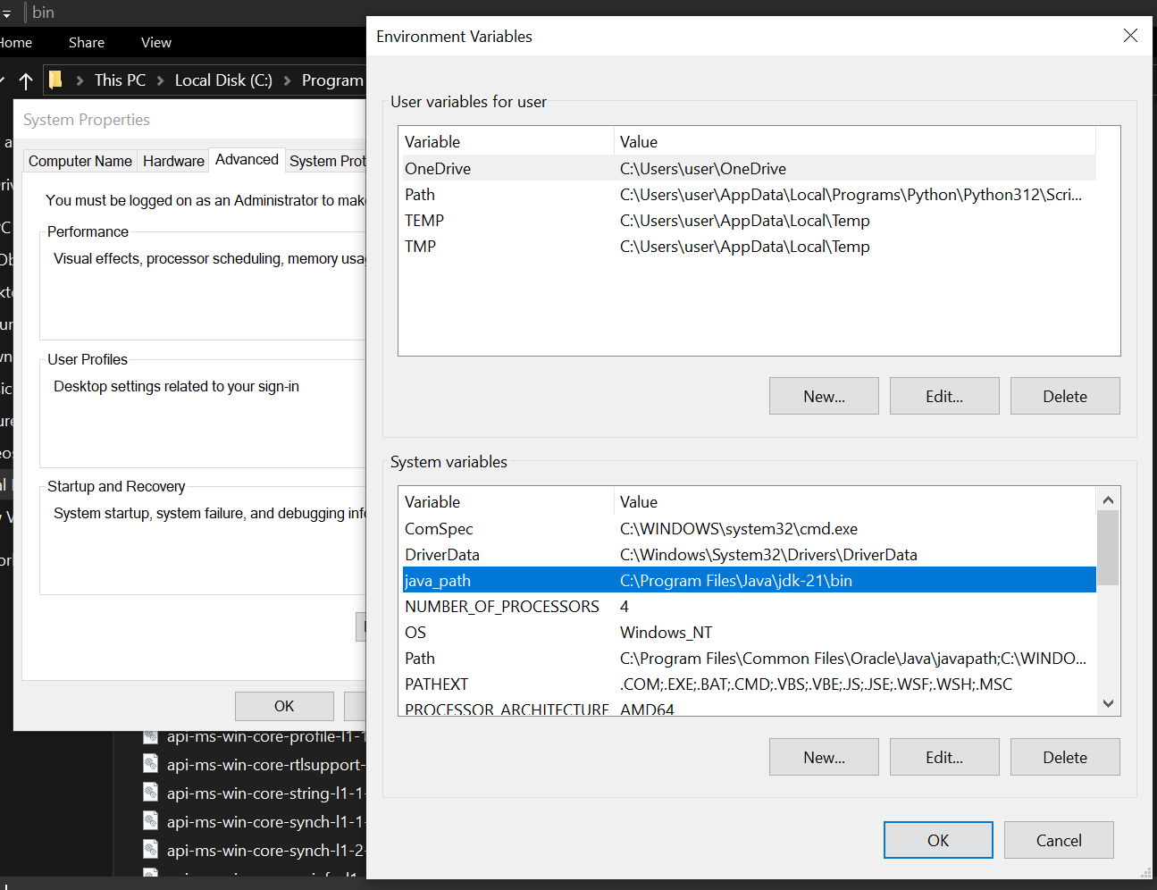

**Checking of JDK Version:**

1. **Open Command Prompt:**
   * Press win+R, type cmd, and press Enter.
2. **Check Version:**
   * Type java --version and press Enter.
   * Type javac --version and press Enter.

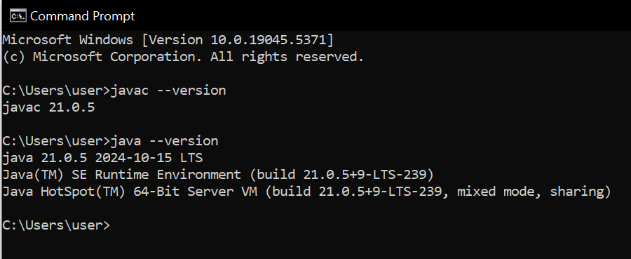

**2) Simple Java Program for printing Name, Class, Roll No, of a Student**

Write your code in Notepad and execute in cmd prompt

**CODE:**

class Main

{

public static void main(String[] args)

{

System.out.println("Name: Manideep");

System.out.println("Section: CSE-B");

System.out.println("Roll No : 24108");

}

}

**Output:**

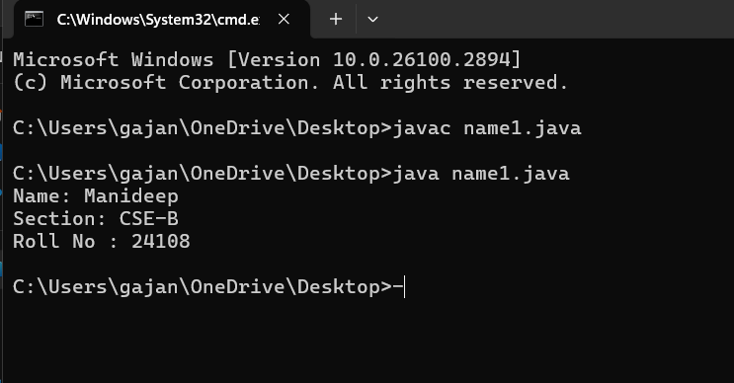

**WEEK-2**

1. **Simple Java Program for finding simple interest by taking input from User ?**

**Code:**

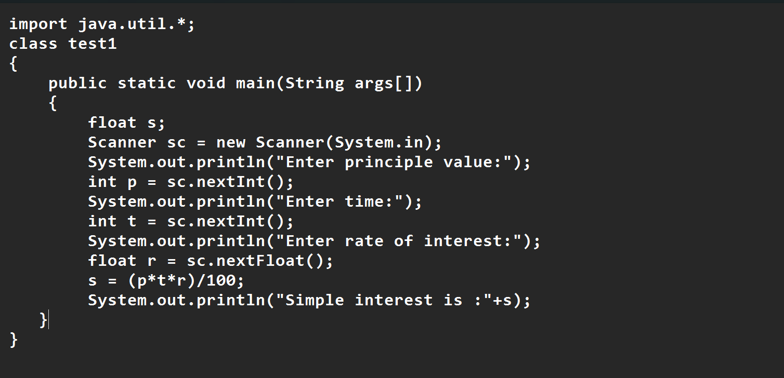

**Output:**

|  |  |  |  |
| --- | --- | --- | --- |
| S.No | Error type | Reason for error | rectification |
| 1 | Runtime error | Incorrect path | Copied correct path |
| 2 | Syntax error | { missing | { added |
| 3 | Logical error | Wrong formula | Formula rectified |

**2.Write a simple program to calculate factorial of a number and read the input from user ?**

**code:**

**Output:**

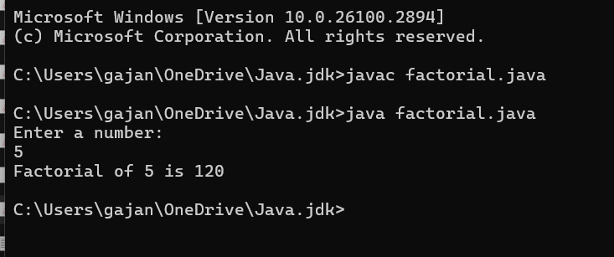

|  |  |  |  |
| --- | --- | --- | --- |
| **S.No** | **Error type** | **Reason for error** | **Rectification** |
| **1** | **Undeclared variable error** | **Missing variable** | **Variable declared** |
| **2** | **Missing import statement** | **Not importing packages** | **Packages imported** |
| **3** | **Logical error** | **Wrong formula** | **Formula rectified** |

**3.Write a program to to calculate the fibonacii sequence and take the input from user ?**

**Code:**

**Output:**

|  |  |  |  |
| --- | --- | --- | --- |
| **S.No** | **Error type** | **Reason for error** | **Rectification** |
| **1** | **Logical error** | **Incorrect formula** | **Formula rectified** |
| **2** | **Run-time error** | **Incorrect path** | **Added correct path** |

**4).Write a java program to convert temperature from Fahrenheit to celsius and take the input from user ?**

**Code:**

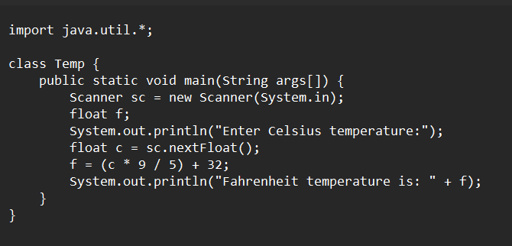

**Output:**

|  |  |  |  |
| --- | --- | --- | --- |
| **S.No** | **Error type** | **Reason for error** | **rectification** |
| **1** | **Syntax error** | **Missing ”** | **“ is added** |
| **2** | **Missing import error** | **Util package missing** | **Util package added** |

**5).Write a simple program to find the area of rectangle and take the input from user ?**

**Code:**

**Output:**

|  |  |  |  |
| --- | --- | --- | --- |
| **S.No** | **Error type** | **Reason for error** | **Rectification** |
| **1** | **Syntax error** | **Semi colon missing** | **Semi colon added** |

**6).Write a java program to convert temperature from Celsius to Fahrenheit**

**Code**

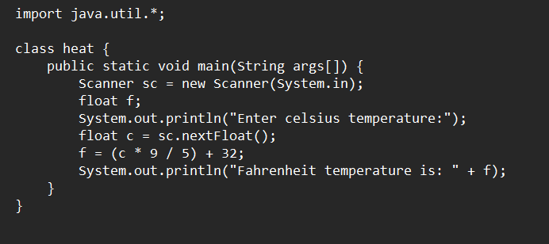

**Output:**

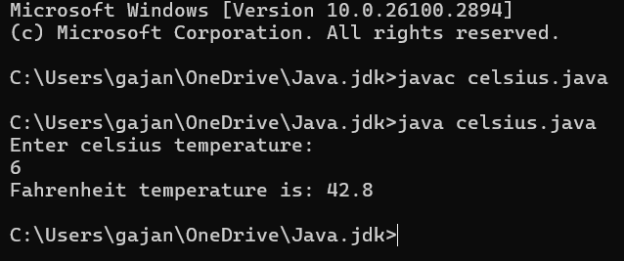

|  |  |  |  |
| --- | --- | --- | --- |
| **S.No** | **Error type** | **Reason for error** | **Rectification** |
| **1** | **Runtime error** | **Incorrect path selection** | **Correct path added** |
| **2** | **Logical error** | **Incorrect logic** | **Correct logic** |

**7).Write a program to find the area of triangle by using heron’s formula take the input from the user**

**Code:**

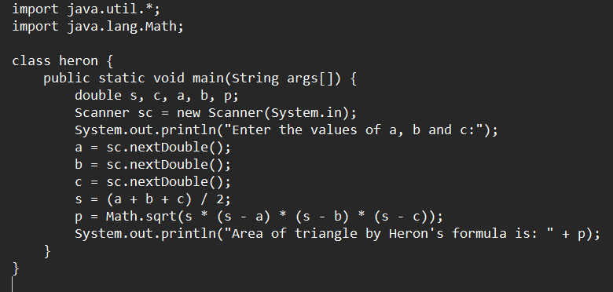

**Output:**

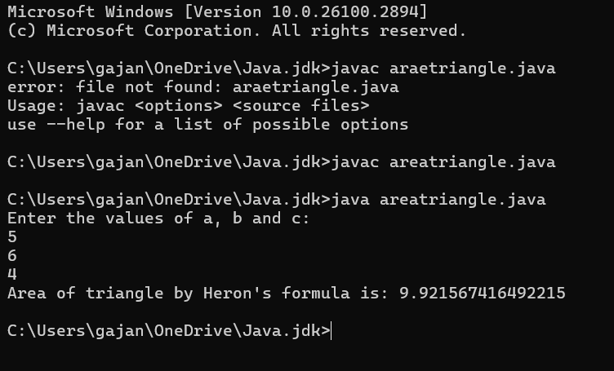

|  |  |  |  |
| --- | --- | --- | --- |
| **S.No** | **Error type** | **Reason for error** | **Rectification** |
| **1** | **Logical error** | **Incorrect formula** | **Formula rectified** |
| **2** | **Name error** | **Undeclared variable** | **Variable declared** |

**WEEK-3**

**Aim:**

**1) create a java program with following instructions**

**a.Create a class with name car**

**b. Create four attributes named car_color ,Car_brand,fuel_type,mileage**

**c. Create three methods named start(), stop(). Service()**

**d. Create three objects named car1,car2 and car3**

**2). To create a class bankAccount with methods deposit() and withdrawl ?**

**Code:**

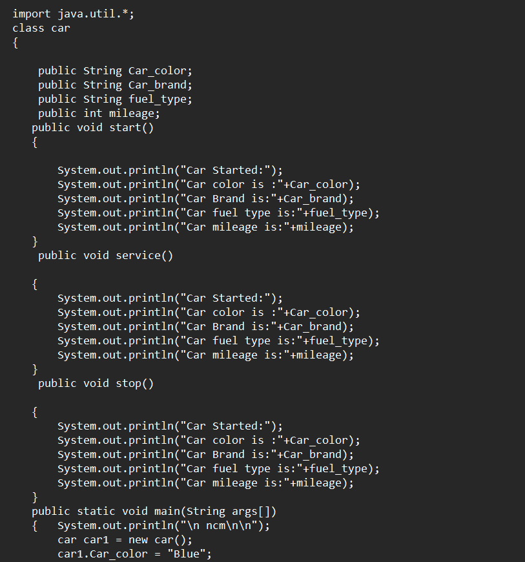

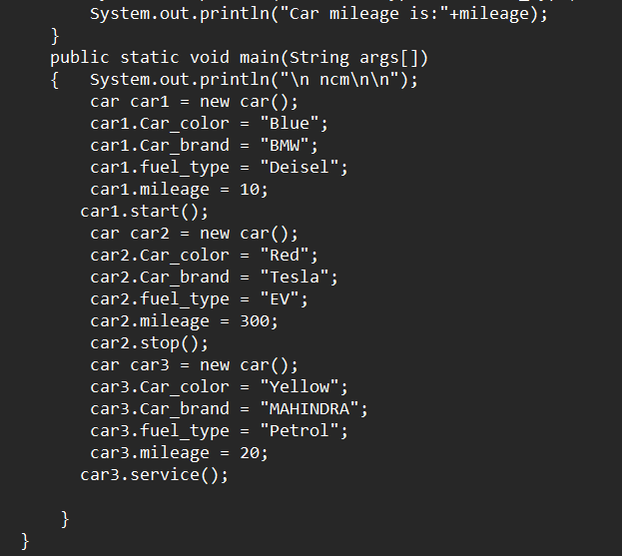

**Output:**

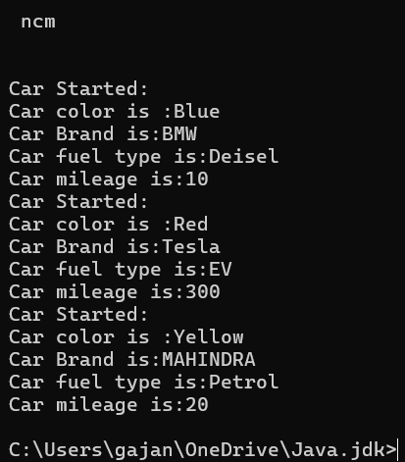

**Errors:**

|  |  |  |  |
| --- | --- | --- | --- |
| **S.No** | **Error type** | **Reason for error** | **Rectification** |
| 1 | **Name error** | **Undeclared variable** | **Variable declared** |
| **2** | **Run time error** | **Incorrect path decloration** | **Correct path declared** |
| **3** | **Syntax error** | **Semi colon missed** | **Semi colon added** |
| **4** | **Syntax error** | **Missing “** | **Added “** |
| **5** | **Syntax error** | **Int missing** | **Int added** |

**Important points:**

* Variable name mismatch: The variable car_Color in the code should be car_color
* Incorrect variable name: car1.car_color is used when the actual variable is car1.car_Color, which will cause an error due to case sensitivity.
* Missing Semicolon: Forgetting to add a semicolon at the end of a statement will cause a compilation error.

**CLASS DIAGRAM-**

|  |
| --- |
| **car**  **-----------------------**  **-car_color:string**  **-car_brand:string**  **-fuel_type:string**  **-milage:double**  **----------------------**  **+start():void**  **+stop():void**  **+service():void** |

**2).To create a class bankAccount with methods deposit() and withdrawl ?**

**code:**

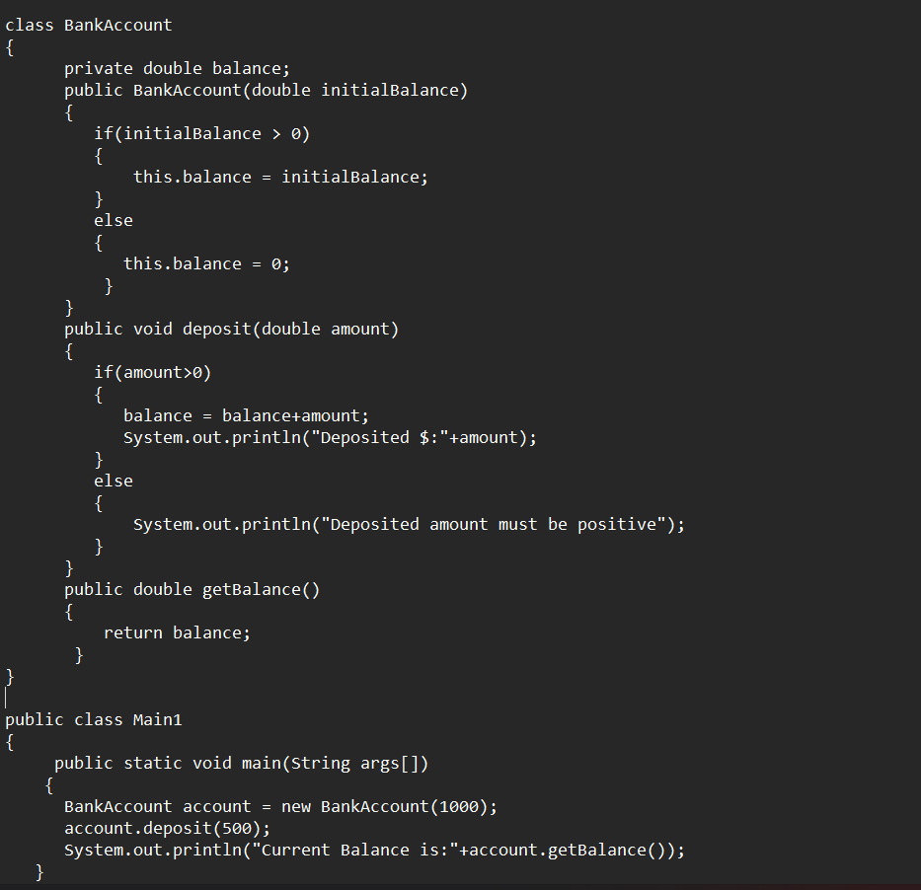

**Output:**



**Errors:**



**Important points:**

* The balance should be a float or double to handle decimal values correctly, but it's declared as an int.
* Incorrect deposit method signature: The method DEPOSIT () has an incorrect return type int(), while it should be void since it doesn't need to return any value.
* Fixed the return type of deposit: Changed from int to void, as the method does not need to return anything

**CLASS DIAGRAM-**

**WEEK-4**

**1. Write a Java program with a class named Book**

**a) a class should contain various attributes such as title, author, and year of publication.**

**b) it should also contain a constructor with parameters which initialize the title, author, and year of publication.**

**c)create a method which displays the details of the book title, author, year of publication**

**Display the details of two books.**

**CODE:**

**Output:**

**Error:**

|  |  |  |
| --- | --- | --- |
| **SI.NO** | **ERROR MESSAGE** | **ERROR RECTIFICATION** |
| 1. |  |  |
| 2. |  |  |

**Important points:**

* While defining two classes for a code, we must be sure that we save both the classes in separate files.
* While defining a method we should also define a function to call that method.

**CLASS DIAGRAM-**

|  |
| --- |
| Book   * Title: String * Author: String * Year of publication: int   + Book(title: String,  Author: String;  Year of publication: int  + displayDetails( ): void |

**2). Create a Java program with a class named ‘MyClass’ with a static variable count of int type, initialized to zero and a constant variable ‘pi’ or type double initialized to 3.14 as attributes of the class. Now define a constructor for “MyClass” that increments the count variable each time an object of MyClass is created. Finally, print the final values of the count and pi variables. Create three objects and a constructor.**

**CODE:**

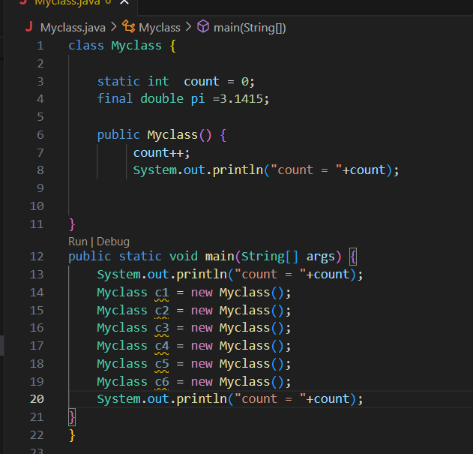

**Output:**

**Error:**

|  |  |  |
| --- | --- | --- |
| **SI.NO** | **ERROR MESSAGE** | **ERROR RECTIFICATION** |
| **1.** |  |  |
| **2.** | **error: can't find primary (String []) method in class: SimpleInterestCalculator** | **Should close the string brackets []** |

**Important points:**

* **We must declare the initial value of the variable before declaring the final one.**
* **Here the main objective is to increase the count according to the number of objects we make, i.e the count increases when the no.of objects are increasing.**

**CLASS DIAGRAM-**

|  |
| --- |
| Myclass   * Count: int * Pi: double   + myclass( )  + main(args: String[]): void |